**Semester 1 (Unit 3) Examination, 2017**

**Question/Answer Booklet**

**MATHEMATICS METHODS**

**Section One: Calculator-free**

Student Name/Number: ______________________________________________

Teacher Name: ______________________________________________

**Time allowed for this section**

Reading time before commencing work: five minutes

Working time for this section: fifty minutes

**Materials required/recommended for this section**

**To be provided by the supervisor:** This Question/Answer Booklet

Formula Sheet

**To be provided by the candidate:**

Standard items: pens (blue/black preferred), pencils (including coloured), sharpener, correction fluid/tape, eraser, ruler, highlighters

Special items: nil

**Important note to candidates**

No other items may be taken into the examination room. It is **your** responsibility to ensure that you do not have any unauthorised notes or other items of a non-personal nature in the examination room. If you have any unauthorised material with you, hand it to the supervisor **before** reading any further.

**Structure of this paper**

|  |  |  |  |  |  |
| --- | --- | --- | --- | --- | --- |
| Section | Number of questions available | Number of questions to be answered | Working time (minutes) | Marks available | Percentage of exam |
| Section One: Calculator-free | 7 | 7 | 50 | 50 | 35 |
| Section Two: Calculator-assumed | 11 | 11 | 100 | 100 | 65 |
|  | | | | | 100 |

**Instructions to candidates**

1. The rules for the conduct of School exams are detailed in the *_______________________________________School/College assessment policy*. Sitting this examination implies that you agree to abide by these rules.
2. Write your answers in this Question/Answer Booklet.

3. You must be careful to confine your responses to the specific questions asked and to follow any instructions that are specific to a particular question.

1. Spare pages are included at the end of this booklet. They can be used for planning your responses and/or as additional space if required to continue an answer.
   * Planning: If you use the spare pages for planning, indicate this clearly at the top of the page.
   * Continuing an answer: If you need to use the space to continue an answer, indicate in the original answer space where the answer is continued, i.e. give the page number. Fill in the number of the question that you are continuing to answer at the top of the page.
2. **Show all working clearly.** Your working should be in sufficient detail to allow your answers to be checked readily and for marks to be awarded for reasoning. Incorrect answers given without supporting reasoning cannot be allocated any marks. For any question or part question worth more than two marks, valid working or justification is required to receive full marks. If you repeat any question, ensure that you cancel the answer you do not wish to have marked.
3. It is recommended that you **do not use pencil**, except in diagrams.
4. The Formula Sheet is **not** to be handed in with your Question/Answer Booklet.

**Section One: Calculator-free (50 Marks) Weighting 35%**

This section has **7 (seven)** questions. Answer **all** questions. Write your answers in the spaces provided.

Suggested working time: **50 minutes**.

**Question 1 (7 marks)**

(a) Determine given that

(i)  (2 marks)

(ii)  (2 marks)

(b) Evaluate  given that . (3 marks)

**Question 2 (6 marks)**

A heavy container is being dragged along a horizontal surface by a chain which makes an angle $θ$ with the horizontal ().

$F$

$θ$

The force, $F$ Newtons, exerted on the chain is given by



Determine the minimum possible value of the force $F.$

**Question 3 (8 marks)**

A particle is undergoing rectilinear motion where the velocity m s-1 at time t seconds is given by

 for .

(a) When is the particle first at rest? (2 marks)

(b) What is the initial acceleration of the particle? (2 marks)

(c) Will the particle ever return to its starting point? Justify your answer. (2 marks)

(d) How far does the particle travel in the first 10 seconds? (2 marks)

**Question 4 (11 marks)**

Jamie is a keen darts player. For a competition, the dart board consists of a square of side length cm and is partitioned as shown below.

Note: the quarter circle and the triangle meet at the mid-way point of the square.

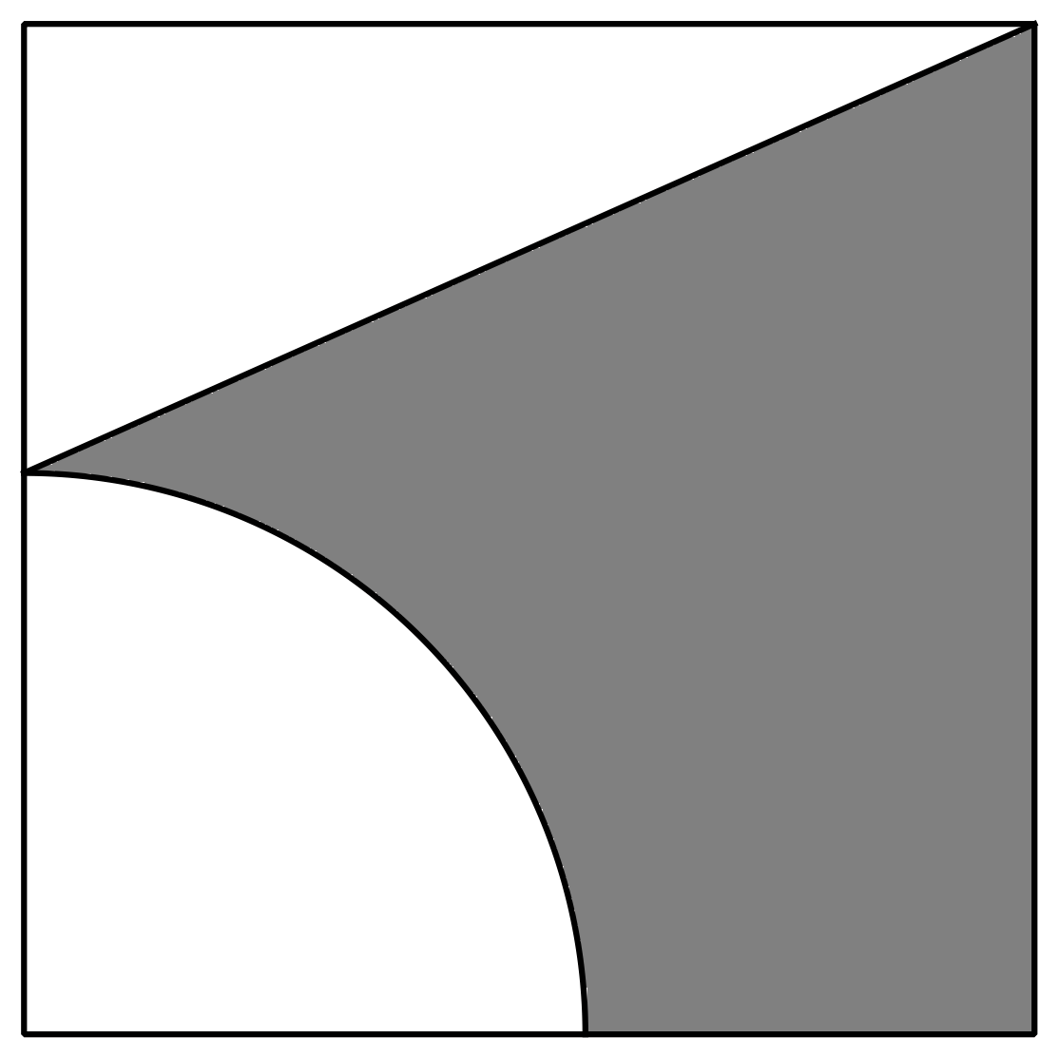

A dart is considered equally likely to hit any part of the square board, and all darts are assumed to land within the square.

1. Show that the probability of a dart landing in the shaded area is  (5 marks)

Jamie throws three darts.

Determine, in terms of , the probability that:

(b) Jamie’s first and third throws land within the shaded area and the second throw outside the shaded area. (2 marks)

(c) Jamie hits the shaded region only once in three throws. (2 marks)

(d) hits the shaded region at least once with his three throws. (2 marks)

**Question 5 (8 marks)**

Determine the following indefinite integrals.

(a)  (2 marks)

(b)  (2 marks)

(c)  (2 marks)

(d)  (2 marks)

**Question 6 (4 marks)**

Using the trigonometric identities  and ,

determine 

**Question 7 (6 marks)**

Determine the following

(a)  (2 marks)

(b)  (2 marks)

(c)  (2 marks)

**End of Questions**

Additional working space

Question number: __________________

**Acknowledgements**

© MAWA, 2017

This examination is Copyright but may be freely used within the school that purchases this licence.

* The items that are contained in this examination are to be used solely in the school for which they are purchased.
* They are not to be shared in any manner with a school which has not purchased their own licence.
* The items and the solutions/marking keys are to be kept confidentially and not copied or made available to anyone who is not a teacher at the school. Teachers may give feedback to students in the form of showing them how the work is marked but students are not to retain a copy of the paper or the marking guide until the agreed release date stipulated in the purchasing agreement/licence.

*Published by The Mathematical Association of WA*

*12 Cobbler Place, MIRRABOOKA 6061.*